***Shaadi.com Analysis***

There are top 10 matrimony site per visitor, shaadi.com one of them five below the image shows:

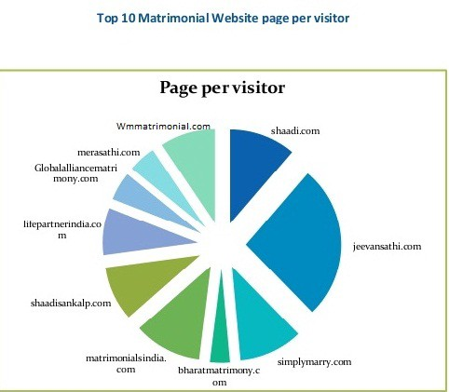



Shaadi.com operator is a matchmaking platform that intended to provide clients with their perfect match. This company provide matchmaking platform that performs intensive research and analysis on each client before posting their profile on the portal, enabling clients to avoid fraud.

Their currently trending news that nokari.com is new competitor of shaadi.com

New members at shaadi.com in July 2020 in comparison:

Here you can see how membership figures at shaadi.com are developing compared to others.

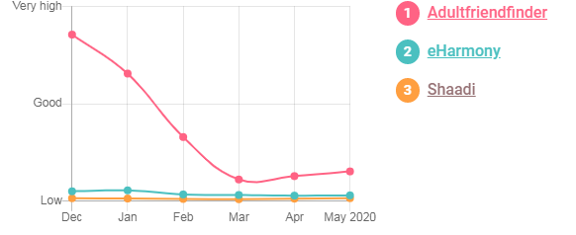

Member activity at shaadi.com in July 2020 in comparison

This is how active shaadi.com member compare to other

